EON-XR PLATFORM DESIGN BRIEF

A GUIDE FOR STUDENTS
Using the EON-XR Platform for Assignments

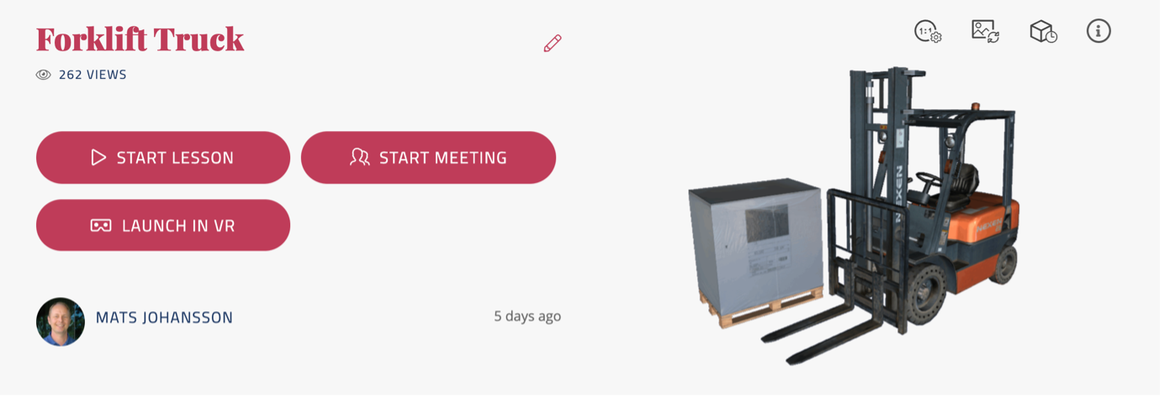

Contents
A GUIDE FOR STUDENTS 1
A GUIDE FOR STUDENTS TO BUILD CREATOR EON-XR LESSONS FOR ASSIGNMENTS 3
INTRODUCTION 3
HOW CAN THIS GUIDE HELP ME? 3
PLANNING YOUR ASSIGNMENT 4
CREATING LEARNING SEQUENCES 7
GUIDELINES FOR PRODUCING QUALITY LESSONS (CRITERIA) 9
Qualitative Criteria 9
Quantitative Criteria 10
SELF AND PEER EVALUATION 10
Qualitative Grading Criteria 11
Quantitative Grading Criteria 12

A GUIDE FOR STUDENTS TO BUILD CREATOR EON-XR LESSONS FOR ASSIGNMENTS

INTRODUCTION
The following guide gives you some pointers as to how to build an EON-XR Lesson for an assignment. The purpose of these lessons is to enable you to learn through constructing lessons that someone else might learn from – in other words, you are being put in the position of being an instructor.
There are four main steps to building a lesson, after you have been given the instructions about the assignment from you instructor: planning, researching, building the lesson, then sharing with your peers, evaluating each other and being evaluated by the instructor.

a
Table 1 Four-step process to develop lessons

HOW CAN THIS GUIDE HELP ME?
We assume that you have already undergone training in how to use the EON-XR Platform – that is, you know how to use the functionality to create a 3D lesson or a 360 lesson. In this guide we want to provide support for building a lesson that has meaning, and from which you can create a good assignment.
Note that it is your instructor who is the expert in the subject content and discipline area; we just want to make suggestions for how the EON-XR Platform can support creating meaningful content for others.
If you follow the steps in this guide, it will help you to think carefully about what you are doing, plan your lesson, do the research, and evaluate your work (and that of your peers) against a set of standards.
The EON-XR Platform has several possible functionalities and activities. (See Table 2, below.) Well constructed experiences will use as many of these as possible. Of course, the topic might not always suit using all the functions and activities, but it is advisable to use as many as you can. Why is this? Because we learn best through maximising the kinds things we do to learn, so the more different activities we do on the one topic, the better the learning.
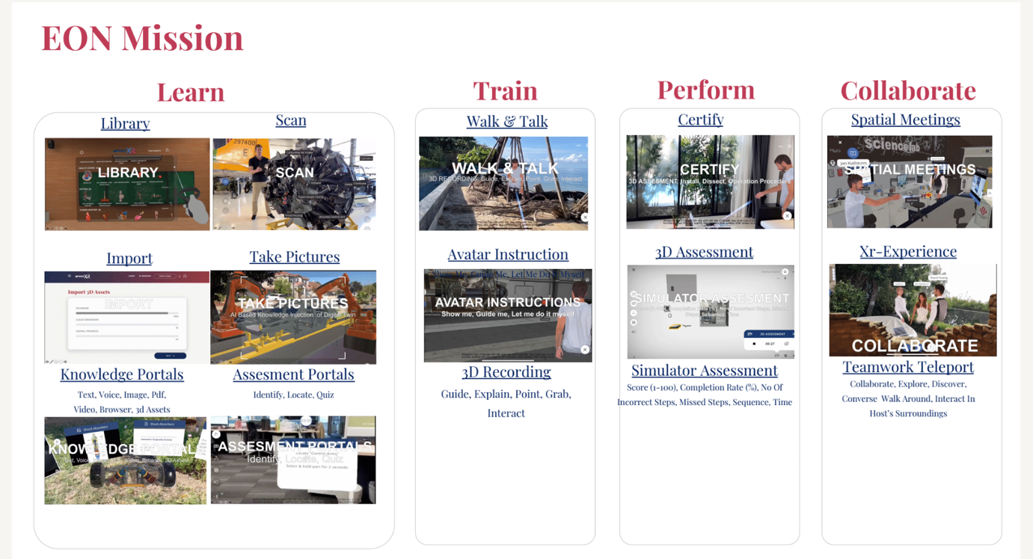

Table 2 functions and activities in the EON-XR Platform
A lesson that, for example, simply had an introduction would not be interesting, nor would a lesson that only consisted of a video or two. The real interest is in using the model (or 360 photo) as the centre-point of the lesson.

PLANNING YOUR ASSIGNMENT
The lesson Planning Template below will help you to be clear about what it is you are trying to achieve with the lesson and also help you in deciding how a learner using the lesson (one of your peers) will use it. See the how-to-use guides in blue italics in the table cells.
LESSON INTRODUCTION: (Applications, how to use EON-XR, Other Lesson Context)
Enter Introduction Text Here:
Here you can give a general introduction about the lesson describing what the topic and why it might be interesting for a learner to know about. What do you hope will be achieved by creating this lesson?
INTENDED LESSON LEARNING OUTCOMES/OBJECTIVES: (What do you expect users to know and be able to do by the end of the lesson)
Intended learning tell the person using the lesson what they will be able to do or know by the end of the lessons. They are best if they are kept short and begin with and active verb. For example:
By the end of this lesson you will be able to:
- rebuild a disassembled starter motor
- describe how the starter motor functions
- describe the role of the starter motor in a car

LESSON NAME: | INSTITUTE NAME:  INSTRUCTOR NAME:  COURSE NAME AND NUMBER:  OTHER:
DESCRIPTION: (What will users see, what happens in this lesson?)  Digital Asset/Model Name:  Location: | User Actions and activity sequences (e.g. explore model, Xray, exploded view)  Here, you can give an outline of the important functions you are using in the lesson and why – how will they help in learning. You can also describe the lesson sequences you intend to use (see Creating lesson Sequences) below
INTRODUCTION SCRIPT: (Intro)
The script you use for the introduction is important for not only giving the learner some information but directing the learner to things you think they should pay attention to. (See Creating lesson sequences, below.)
AR APPROACH: (How will learners use AR – in groups, other?)  Are you designing the lesson with AR and or collaborative learning in mind? How will it be used? | VR APPROACH: (How will learners use VR, i.e. headgear, glasses, etc.?)  Are you designing the lesson with VR in mind? How will it be used?
Build:
Models used
In the case of the Build, Identify and Locate functions, describe here how each will be used. As indicated below in Creating Learning sequences, these functions are best used when linked to other activities.

Knowledge Portals: Text, Voice, Images. Pdf, Video, Browser, 3d Assets

Assessment Portals: Identify, Locate, Quiz

3D recording- Guide, Explain, Point, Grab,
Interact

3D Assessment – order of operations | Design and complete assessment
Collaborate – Spatial or XR experience meeting | Collaborate, Explore, Discover,  Converse Walk Around, Interact In  Host's Surroundings
Table 3 LESSON PLANNING TEMPLATE

CREATING LEARNING SEQUENCES
When you create lessons for an assignment, you need to be able to show that you are connecting different activities in the lesson to give meaning to the subject matter.
Here is an example of a possible sequence on a lesson about a starter motor.

Figure 1 EON-XR Platform 3D lesson - Starter Motor
One of the learning outcomes is for users of the lesson to be able to “rebuild a disassembled starter motor” (See Table 3 Lesson Planning Template under Intended Learning Outcomes/Objectives).

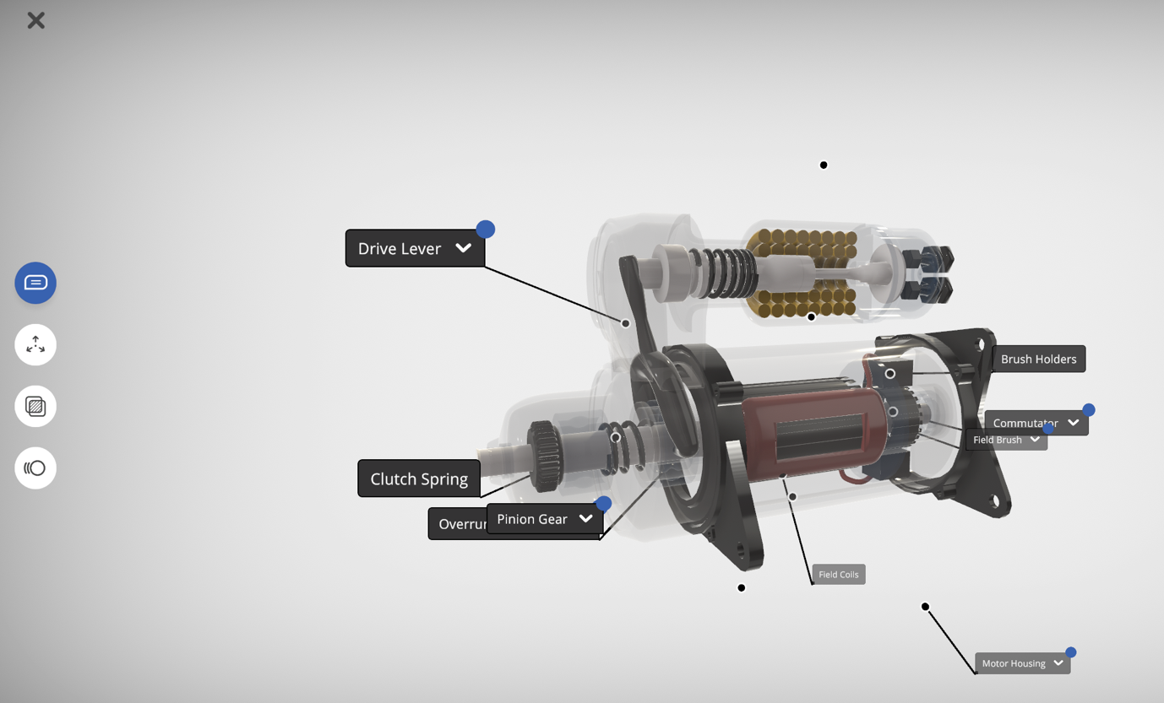
The following figure represents one possible sequence that is designed to achieve this learning outcome through directing attention, observation, constructive activity, and questioning reinforcement. The question you need to ask yourself when you plan the lesson is: “What will the best sequence of activities be for the user to achieve this learning outcome?”
Your lesson may have two or three sequences, or it may be one longer sequence. The point is to think in terms of how the activities support one another to build the user’s learning

Figure 2 Possible Sequence of Activities
- Learn
Upload the starter motor into the lesson. You can also scan a motor and use it later to create a “digital twin” of the motor to add content via the A.I. function. Add content in V.R. and then A.R. such as relevant video, text and a 3D recording.
Once the asset is chosen and in the lesson, you are in create mode. In augmented reality add knowledge portals and assessment portals by using the A.I. function. In the app you will take a picture of the model and choose content to add to the portals.
- Train
Now you can move around the model (walk and talk) and make a 3D recording of your experience. When you play back the recording you will see your avatar doing some of all of the following: guide, explain, point, grab, interact.
- Perform
The actions of taking apart, reassembling, orders of procedures and more can be measured using 3D assessment. Once the order and actions are identified, any user can measure their ability to perform these tasks using 3D assessment, and the results are recorded.

- Collaborate
Learn with others including classmates, instructors, industry experts, etc. Start a spatial meetings (if that license is available) and invite at least one other person in the space. Record the experience (screen recording) to share later. Collaborating can be done using Spatial Meetings or XR-Experience.

The posibility of having learning activity sequences like this is a great strength of the EON-XR Platform for building student learning.

GUIDELINES FOR PRODUCING QUALITY LESSONS (CRITERIA)
If you use the lesson Planning Template and follow these criteria, you have a good chance of producing an engaging EON-XR Platform lesson.
There are two sets of guidelines. The first are what we call qualitative criteria, that is, they describe the qualities such as how well the lesson holds together, how much variety there is in the lesson, how useful the structure is, and how long it holds the user’s attention.
The second setoff criteria are quantitative criteria describing the range and numbers of activities we think support the qualitative criteria and again, lead to an interesting and engaging lesson. A lesson that only has one video, and nothing else, or only has an introduction, is of little interest to a user.

Qualitative Criteria
The qualitative criteria are based on four major qualities for the lesson:
- Coherence
- Structure
- Variety
- Time on Task
These are briefly described in Table 4 following, and again in Table 6 where they are set out as criteria by which you can evaluate yourself and your peers.
Coherence
This refers to the overall unity of the lesson. The lesson needs to have overall meaning in terms of the learning outcomes and the learner should be able to achieve the learning outcomes by the end of the lesson. Coherence also means that what is learned makes sense and has significance. It is not, for example, trivial factual learning.
Structure
This refers to the way the parts of the lesson have been put together so that they inform each other and build learning. A better understanding of this criterion can be gained from reading the section on Creating Learning Sequences.
Variety
This refers to ensuring that the lesson makes the fullest use of all the functionalities available to the lesson. Research indicates that a variety of approaches to learning (different activities and points of view) increases learning engagement. The idea is to create as much interest as possible for the user of your lesson.
Time on Task
This criterion refers to the idea that learning does not happen quickly, and the lesson needs to engage the user for enough time to develop deeper understanding. It is unlikely that a user will learn much from a lesson that requires less than two minutes to do.
Table 4 Qualitative Criteria

Quantitative Criteria
Table 5. below shows the quantitative Criteria. These are, of course linked to parts of the Qualitative Criteria. It is likely that if you fulfill the Quantitative Criteria as set out below, you will also satisfy most of e requirements for Variety, and Time on Task.
Also, if you use the Quantitative Criteria, you will be able to think in learning sequences so that you connect (for example) and activity to locate, with an activity to build, and then an activity to identify, followed by a quiz.

Figure 3 Different possible sequences

Table 5 Quantitative Criteria

SELF AND PEER EVALUATION
Once you have created your lesson, you may be asked by your instructor to share it with peers and to give feedback. You also need to be able to evaluate the quality of your own lesson. In addition to that, if the lesson is for an assignment that will be graded as a contribution to you course grade, you instructor may use the Grading Criteria below to assess you.

Qualitative Grading Criteria
Please note that the following “Grading Criteria” are not necessarily those your instructor will use. We supply them as a way of indicating different levels of performance. You can use these Grading Criteria before you begin creating your lesson, and you can use them afterwards as a form of feedback to yourself, by asking where your lesson fits into the table.
 | Outstanding | Satisfactory | Below Average
Coherence  *Note: the word “activities” here refers to Introduction,  Memo, Build, Locate,  Identify, Quiz | All activities* in the EON-XR Lesson are explicitly directed to achieving the learning outcomes and progressively build knowledge and skill | Activities* are directed to the achievement of the learning outcomes, but without being explicit | It is not clear how the activities* are directed towards achieving the learning outcomes
Structure | The lesson is carefully structured to ensure that learning is reinforced through sequences of connected activities and directing learners’ attention | Although there is a sequence of activities*, they do not have a strong purpose in guiding the learners through the activities | Most of the activities* appear to be randomly and independent of one another.
Variety | The lesson maximises the affordances of the EON-XR Platform by deploying all the appropriate activities at least once | The lesson uses several of the possible and appropriate activities but could have stretched further. | The lesson has limited use of the range of activities available
Time on Task | The lesson is designed so that learners need to take some time to work through it and complete it, taking time to think and explore | The lesson has enough in it to keep the learner engaged, but not deeply absorbed | The learner can finish the lesson quickly because it does not engage their attention
Table 6 Qualitative Grading Criteria/rubrics

Quantitative Grading Criteria
The quantitative criteria form a check list of whether the lesson you have created satisfies the specifications. These are not hard and fast, of course, and different lessons will necessarily require different combinations of activities.

Introduction with Audio Narration & 1 video (1 min in length for each voice-over, either text to speech or voice recording)
Learn - Model added to a lesson, annotated with at least 3 knowledge portals (text, voice, image, pdf, video, browser, 3D assets)
Train – 3D recording walking around and explaining the asset or environment
Perform – Design and perform a 3D assessment with the asset or related asset. Save score to share in next section.
Collaborate – hold a meeting or spatial meeting with others in the 3D space to collaborate, explore, discover, converse and interact with the surroundings.
Share – Make a short video of these experiences and add a voice over if needed to share in class.

Table 6 Quantitative Grading Criteria/rubrics

